Miguel Fernandez Brazon
3/08/26
Module 10.2 Assignment
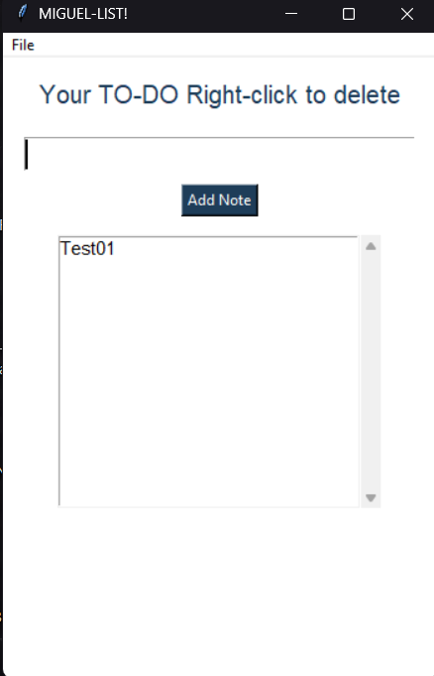
https://github.com/concord808030-tech/CSD-325

